**Vitaldoc Remarks**

|  |  |  |
| --- | --- | --- |
| **No** | **Question** | **Answer** |
|  | Model name/no. of physical scanner? | No physical scanner |
|  | VitalScan through network upload documents and metadata? | Not sure |
|  | VitalScan scan barcode, only fill dsn no? |  |
|  |  |  |

**Upload a document to Vitaldoc by using VitalScan**

1. Open VitalScan, use the barcode scanner to scan the bar code of physical submission, the dsn no. will auto fill in the field DSN.

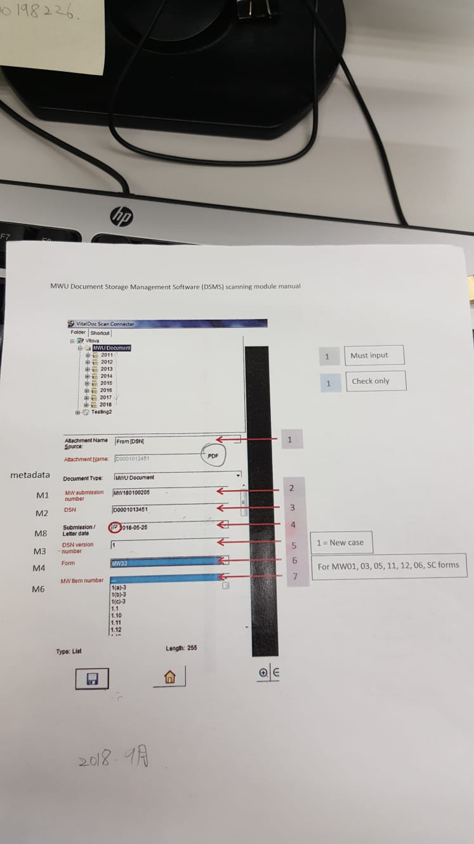

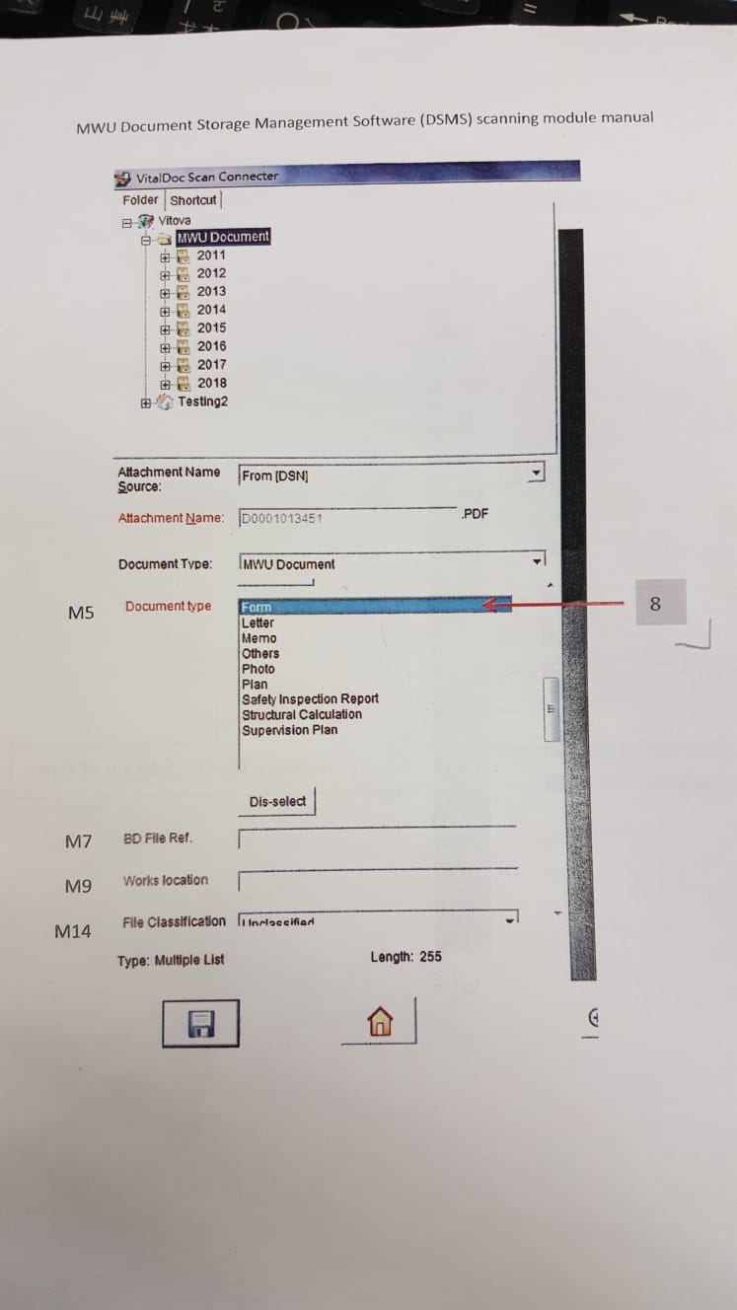

1. Input all required information and save
2. The document will be uploaded in VitalDoc

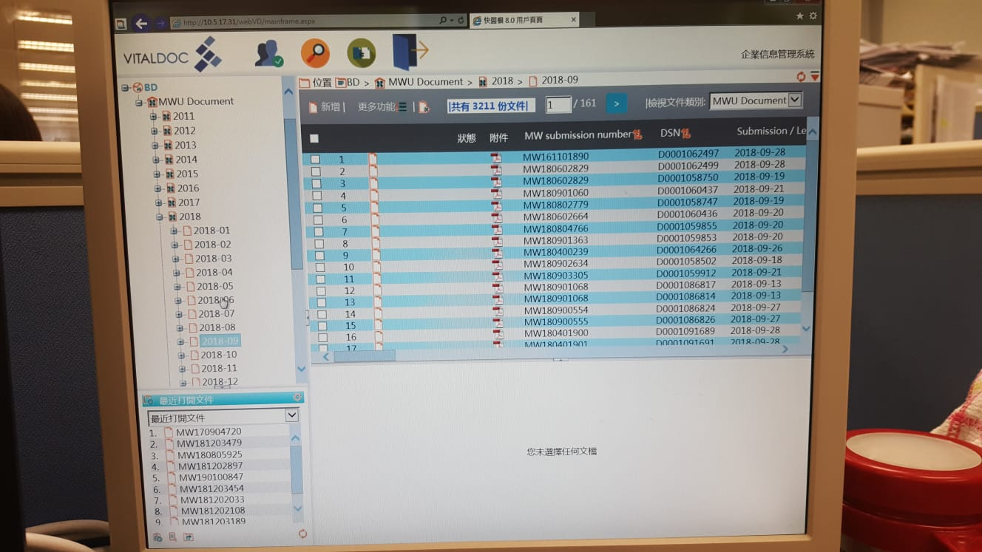

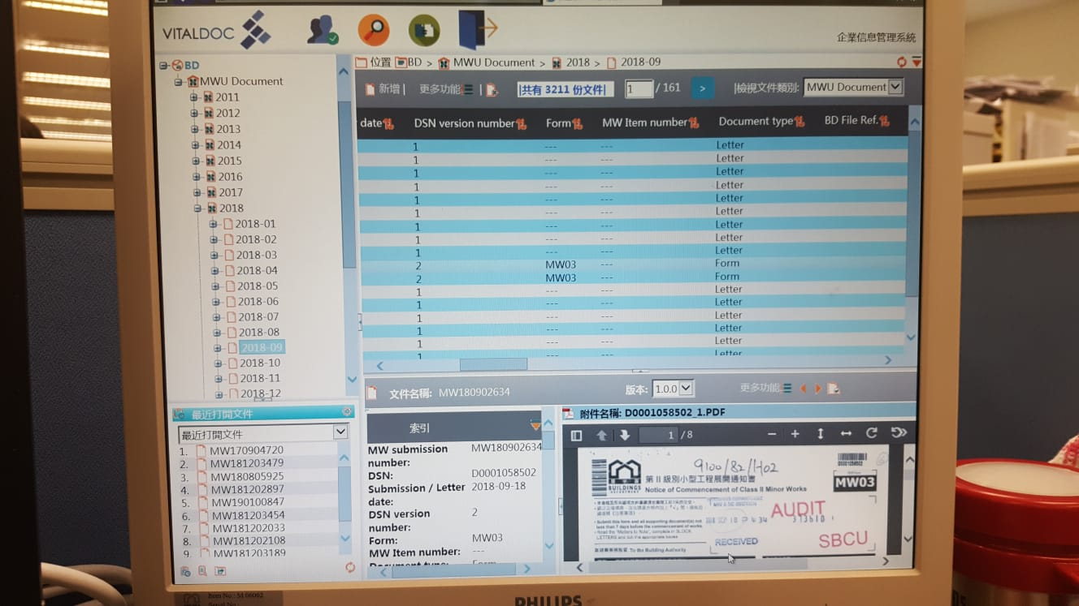

Edit Mode 1

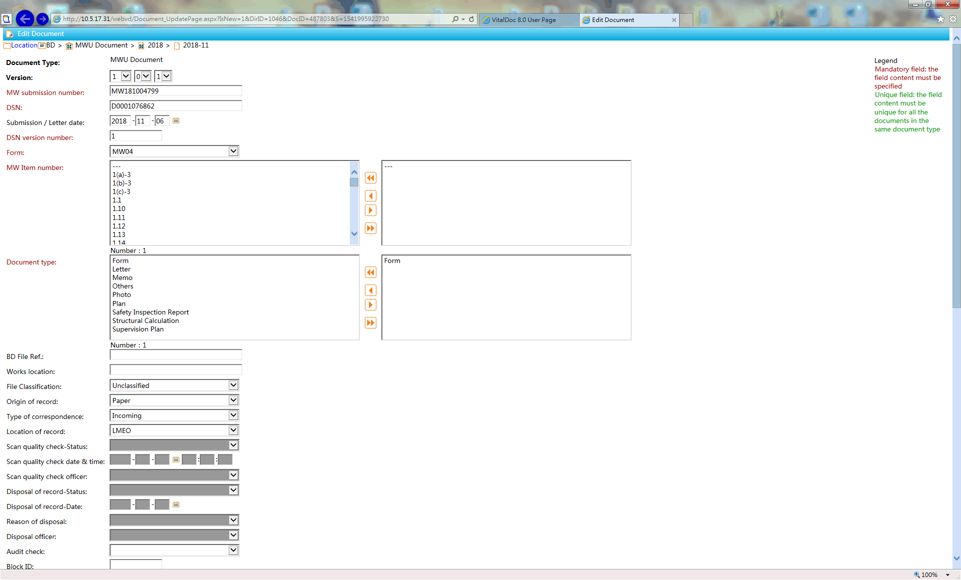

Edit Mode 2 (Continue)

